**[Cam 13] The plans below show the layout of a university’s sports centre now, and how it will look after redevelopment.**

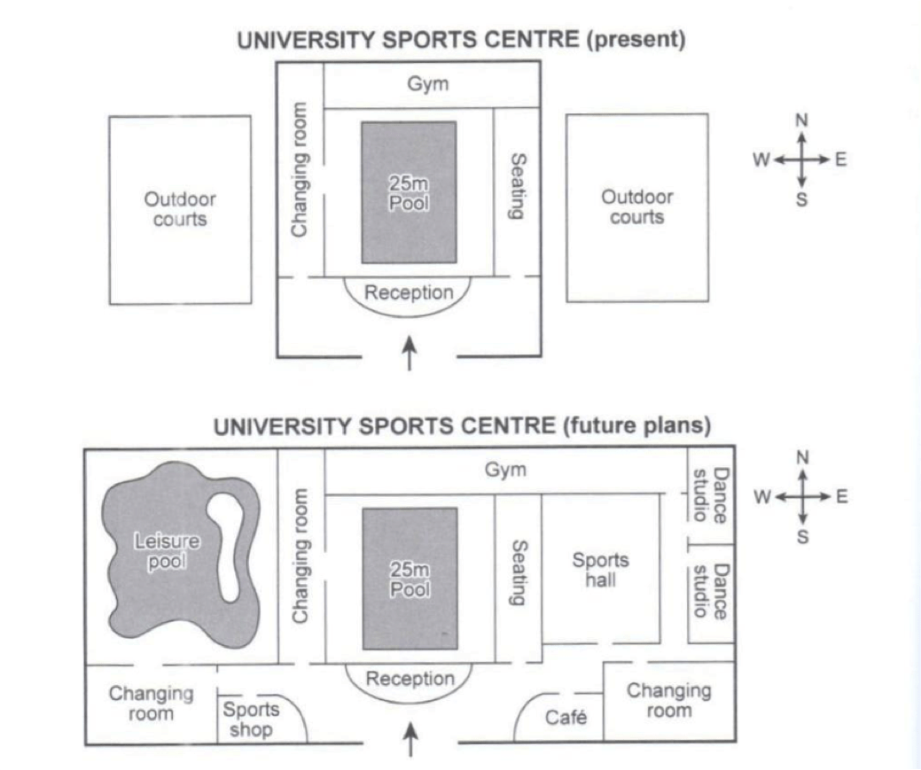

**[OPENING – PARAPHRASING]**

The diagrams illustrate the existing plan of a university’s sports centre and and the proposed plan following the building.

**[OVERVIEW]**

1. General comment
2. Summarize main changes
3. Conclusion

Overall, this sports centre is likely to undergo some significant changes. These include the expansion of the main building and the addition of various sports facilities, **transforming this centre from a basic group of indoor and outdoor facilities into a more comprehensive, totally indoor sports complex.**

**[BODY PARAGRAPH 1 – PRESENT]**

At present, the sports centre is divided into three main areas, with a large building **flanked by** two **open-air playing fields**. **Past** the entrance of the building is a reception desk, which sits in front of a 25-metre swimming pool. Surrounding the pool is a changing room on the left, a seating area on the right, and a gymnasium located **at the upper end of** the structure.

**[BODY PARAGRAPH 2 - FUTURE]**

In the future, many improvements are planned in the centre, with all facilities becoming **encompassed** in a structure **more than double the size of** the original main building. On the original site of the western outdoor courts, a large leisure pool will be constructed, while a big sports hall **is set to** replace built the other court. The gymnasium **is to be expanded** to the east, reaching two new **adjacent** dance studios **housed** at the eastern end. Additionally, the front part of the expanded building will include a sports shop, a café, and two new changing rooms.